**HALE SCHOOL YEAR 12 PHYSICS**

**SECTION 1**

Question 2: (4 marks)

A musician at a party plays a steady note on a wind instrument by blowing into the instrument and exciting a fundamental tone with a frequency of 440 Hz. She then plays a party trick by inhaling helium gas from a balloon and blowing into the instrument again to excite the fundamental tone. Estimate the frequency emitted by the instrument when it is filled with helium. Show working. (vHelium = 985 ms-1)

Question 3: (5 marks)

The figure below shows an apparatus that can be used to find the speed of sound. Part B is moveable relative to Part A. Sound produced by the loudspeaker travels through parts A and B separately to reach the ear at D.

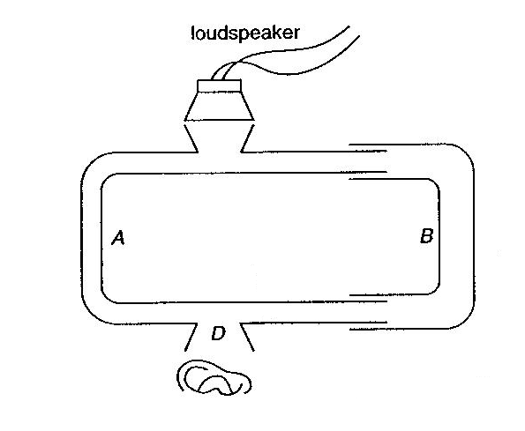

1. When part B moves, the intensity at D rises and falls alternately. Explain this. (2)

________________________________________________________________________________________________________________________________________________________________________________________________________________________________________________________________________________________________

1. How can the wavelength of sound be found? Explain. (2)

________________________________________________________________________________________________________________________________________________________________________________________________________________________________________________________________________________________________

1. How can the speed of sound be found? Explain. (1)

________________________________________________________________________________________________________________________________________________

Question 4: (4 marks)

What category or type of electromagnetic wave is usually involved in each of the following?

1. Reflection from the ionosphere. _______________________________
2. Seeing objects with the naked eye. _______________________________
3. Communicating by retransmitting from satellites.______________________________
4. Causing skin cancer. _______________________________
5. Treating cancers. _______________________________
6. Detecting cracks in welds. _______________________________
7. Producing heat to help overcome injury. _______________________________
8. Operating radar systems. _______________________________

Question 5: (4 marks)

The coils shown below are wound on soft iron cores. A current carrying wire is placed between the coils as indicated. Show on the diagram:

1. Direction of conventional current
2. Magnetic Poles
3. Magnetic Fields produced, and
4. Direction the Conductor will move

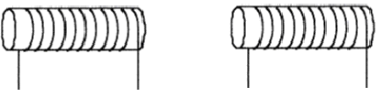

Question 6: (4 marks)

Carefully study the diagram.

1000 turn Coil

Laminated soft iron bar

Aluminium ring (full of water)

**240V AC**

a) When the power is switched on at the 240V AC source, the water in the aluminium ring   
 begins to heat up and eventually boils. Fully explain this phenomenon. (2)

____________________________________________________________________________________________________________________________________________________________________________________________________________________________________________________________________________________________________________

b) If the 240V AC is replaced by a 12V DC car battery, the water will not heat up at all.   
 **Explain**. (2)

____________________________________________________________________________________________________________________________________________________________________________________________________________________________________________________________________________________________________________

Question 7: (4 marks)

A 10cm square coil (20 turns; RTotal=15Ω) is regularly pushed in and out (constant speed) of a uniform magnetic field of 2.0T every 10 microseconds (i.e. one complete cycle in that time). The field is perpendicular to the coil.

What is the magnitude of the current that is induced in the coil?

X X X X X

X X X X X

X X X X X

Question 8: (3 marks)

When a matter / antimatter pair collide (e.g. an electron and a positron), total annihilation occurs and gamma rays are produced. This is called pair annihilation. But the opposite can also happen. When a high energy gamma ray photon passes through a strong magnetic field, it may convert into a matter/antimatter pair. This process is called **pair production**.

Two gamma rays enter a region of strong magnetic field. One is converted into an electron-positron pair. The other produces a proton-antiproton pair.

Calculate the ratio of the energies for the two gamma ray photons. Assume in each case that the particles produced have zero kinetic energy.

Question 9: (3 marks)

The metal aluminium has ionisation energy of 4.13 eV. If light with a frequency exactly 3 times that required to produce photoelectrons of effectively zero kinetic energy is used, what is the maximum velocity of these photoelectrons?

Question 10: (4 marks)

Electrons of energy 12.0 eV are fired through a vapour of atoms and the energies of scattered electrons are measured as 12.0 eV, 7.2 eV, 4.1 eV, and 1.0 eV.

From this data, draw an energy level diagram for the atoms in the vapour.

Question 11: (4 marks)

With the aid of a diagram, explain the mechanism that causes fluorescence.

________________________________________________

________________________________________________

________________________________________________

________________________________________________

Question 12: (4 marks)

Every 2.5 years, the supergiant star ζ (zeta) Aurigae eclipses its small bright companion. For several weeks, at the beginning and end of the eclipse, the small star can be observed through the transparent outer atmosphere of the supergiant.

Describe, and carefully explain, the differences between the spectrum of the small star when viewed on its own compared to its spectrum when it is observed through the outer atmosphere of its giant companion.

_______________________________________________________________________________________________________________________________________________________________________________________________________________________________________________________________________________________________________________________________________________________________________________________

Question 13: (4 marks)

Find the centre of mass of the uneven dumbbell shown.

30 cm

Data: Large sphere: radius = 6 cm, mass = 3kg

Small sphere: radius = 4 cm, mass = 2 kg

Rod: length = 30cm, mass = 800 g

Question 14: (8 marks)

Hospitals use linear particle accelerators to generate high energy beams that can be used in the treatment of cancer.

One treatment beam uses high energy electrons. An electron is accelerated in

the linear accelerator from rest using 2 GeV of energy.

a) Calculate the velocity of the electrons in this beam, if it were given 2 GeV of energy and   
 classical non-relativistic mechanics equations were applied.

(2)

b) Discuss the feasibility of your answer to part (a). (2)

________________________________________________________________________________________________________________________________________________________________________________________________________________________________________________________________________________________________________

c) Discuss how Einstein’s equation E = mc2 applies to the fast moving electrons in the   
 beam. (2)

____________________________________________________________________________________________________________________________________________________________________________________________________________________________________________________________________________________________________________

d) Calculate the mass increase of the electrons in the beam. (2)

**SECTION 2**

Question 1: (14 marks)

A cyclotron is a particle accelerator that uses a strong magnetic field to deflect charged particles from the ion source through a circular path. Each time an ion crosses from one 'dee' to the other it gains energy from the electric field and increases speed before eventually leaving the cyclotron at a tangent to the ‘dees’ towards a target.

This is achieved by timing the reversal of the polarity of the ‘dees’ to coincide with each half cycle of the ion. The time taken for an ion to complete one cycle is given by where 'v' is the speed of the ion.

a) Starting with the knowledge that as the ion passes through the magnetic field it   
 experiences a centripetal force due to the magnetic interaction, show that the frequency of   
 revolution is given by f where 'q' is the charge on the ion, 'B' is the magnetic flux   
 density of the field and 'm' is the mass of the accelerated particle.

(4)

b) A **doubly charged** positive ion has mass of 3.34 x 10-27 kg. If the maximum radius of a   
 cyclotron is 50.0 cm, what magnetic flux density must be generated in order for the   
 particle to acquire 6.00 x 106 eV of energy?

(7)

c) What frequency must the cyclotron oscillator maintain if it is to be in resonance with the   
 circulating particles?

(3)

Question 2: (14 marks)

a) (i) State the single fundamental difference in construction between a simple DC motor   
 and a simple AC motor. (1)

__________________________________________________________________________

(ii) Explain why, in terms of each motor’s operation, this difference in construction exists.

(3)

____________________________________________________________________________________________________________________________________________________________________________________________________________________________________________________________________________________________________________

b) An electric motor purchased in the USA is labelled 110 V DC.

Now assume this motor is plugged into a household power point in Perth and the power   
 turned on.

Describe, and explain, **two (2)** results that would occur in the first few minutes of   
 operation.

____________________________________________________________________________________________________________________________________________________________________________________________________________________________________________________________________________________________________________

(2)

c) Examine the simple motor illustrated below. In this problem, the motor will be used to run   
 a household electric fan.



This motor uses a magnetic field of intensity 8.00 x 10-2 tesla in the region between the poles. The coil in the motor is square and has side length of 10.0 cm. The coil has 220 turns in the winding.

1. Sketch the orientation of the coil in the field if the motor is producing maximum torque. (2)
2. Select, explanation is not necessary, one acceptable maximum torque value for the electric fan motor from the following set of torque values:

0.02 Nm 0.20 Nm 20.0 Nm 200 Nm

My choice is ___________ (2)

1. Using your chosen torque value, calculate the current drawn by the fan motor during normal operation. (2)
2. Sketch a graph of torque (in Nm) as a function of period (in seconds) for one complete rotation through 3600.

(2)

Question 3: (18 marks)

Part A:

A bridge across a river has collapsed. The bridge used to span 30 meter. See diagram.

A stunt driver is instructed to drive his car at a constant speed of 75 kmh-1 up the ramp.

The angle that the ramp makes with the horizontal is 140.

C:\Program Files (x86)\Microsoft Office\MEDIA\CAGCAT10\j0212957.wmf

140

30m

**A**

**B**

**C**

**D**

a) What is the velocity of the car at its highest point? You must justify your answer.

(3)

b) State the acceleration of the car:

1. just before it leaves the ramp? ______________________________
2. just after it leaves the ramp? ______________________________

(3)

c) Suppose the car lands on the far ramp half way along its length at point D in the diagram.   
 How does his speed vary during the stunt? Answer this by circling the appropriate words   
 below.

(i) Speed at B is greater than / equal to / less than the speed at A.

(ii) Speed at C is greater than / equal to / less than the speed at A.

(iii) Speed at D is greater than / equal to / less than the speed at B.

(3)

d) At what minimum speed must the car travel in order to ensure that he clears the gap?   
 (Assume that air resistance is negligible and give your answer in units of kmh-1)

(4)

Part B:

A cricketer hits the ball very hard, causing the cricket ball to impact with the ground 120 m

away. You may assume that the ball was struck from ground level.

If the greatest height reached by the ball is 34 m, then calculate the velocity with which the

ball left the bat.

(5)

Question 4: (16 marks)

Use the table below for this question:

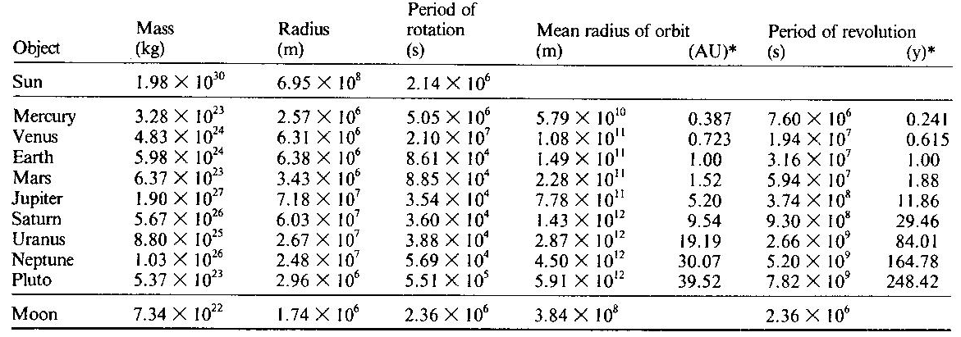

Kepler’s 3rd Law states that the square of the period of the planet [***T2***] is proportional to the

cube of the radius of the orbit [***R3***]. That is , where *K* is a constant.

a) Determine the value of the constant *K* (i.e. ) in each of the following units:

(i) S.I. units for the planet Uranus.

(ii) The units for Earth

(iii) S.I. units for the Moon.

(3)

b) If the value of *K* is a constant, then explain why your answers to part (a) above are not the   
 same.

____________________________________________________________________________________________________________________________________________________________________________________________________________________________________________________________________________________________________________

(2)

c) A satellite is orbiting the Earth west to east **directly** above the equator. To an observer at   
 the equator, the satellite appears to complete exactly 4 orbits in 24 hours.

At what **height** above the Earth’s surface is the satellite orbiting?   
 You may use one of your answers to part (a) to assist you.

(Hint: Don’t forget the rotation of the Earth!).

(5)

d) When large stars go supernova, the remnants may end up as a neutron star; i.e. all the   
 protons and electrons are compressed into neutrons. The neutron stars that we can detect   
 are called Pulsars (after PULSatingstARS) because they pulsate regularly in either the   
 radio or x-ray sections of the electromagnetic spectrum. Pulsars spin very quickly – some   
 of them at rates of thousands of times per second. Pulsars are very small, with a radius   
 between 5k and 15 km. However, their mass is greater than the mass of the sun.

Consider a pulsar of radius 8km and mass equal to 5 times the mass of the Sun:

(i) Calculate the theoretical value for the acceleration due to gravity *g* on its surface.

(1)

(ii) If we assume that it is a millisecond pulsar – i.e. it rotates once on its axis every 0.001   
 seconds, then calculate the value of the centripetal acceleration at the equator.

(2)

(iii) Use your answers to parts (i) and (ii) of this question (part d) to carefully explain the   
 following:

The *measured* value of the acceleration due to gravity *g* will be different at the equator   
 than it is at the poles of any rotating body. What is the main reason for this difference?

______________________________________________________________________________________________________________________________________________________________________________________________________________________________(3)

**Question 5** (14 marks)

A uniform ramp is attached to the back of a truck so that a car can be driven onto the tray of the truck. The ramp is 6.00 m long and has a weight of 4.00 x 103 N with the end of the ramp attached to the tray at a point 1.50m above the ground.

The car has a weight of 1.50 x 104 N and its centre of gravity acts through a point on the ramp located 2.00 m from the top of the ramp.



a) What horizontal force does the truck tray apply to the top of the ramp? (7)

b) What is the magnitude and direction of the reaction force acting at the base of ramp? (7)

Question 6: (10 marks)

In the USA, the first power distribution network used direct current. Modern electrical networks use alternating current.

a) Explain why AC power distribution is preferred.

____________________________________________________________________________________________________________________________________________________________________________________________________________________________________________________________________________________________________________

(4)

b) A generator delivers 180 MW of power. The distribution network has a total line resistance   
 of 8.00 ohm. What is the minimum transmission voltage if power losses are to be   
 maintained below 1.5%?

(6)

Question 7: (14 marks)

A motorbike is travelling at 100 kmh-1 around a flat circular bend of radius 60.0 m. The motorbike and rider have a total moving mass of 240 kg.

a) Draw a fully labelled **diagram** representing the situation showing all Forces acting on the   
 bike and rider.

(2)

b) Calculate the magnitude and direction of the centripetal force acting on the motorbike?

(2)

c) The maximum force of friction, on a dry day, between the tyres and road is 8,580 N.

(i) What is the highest speed (in **kmh-1**) with which the motorbike can travel around the   
 bend without skidding?

(3)

(ii) At what angle from the vertical, at the speed you calculated in part (i) above, are the   
 bike and rider leaning?

(2)

d) If the road is wet then the maximum speed will be less. Explain.

_________________________________________________________________________________________________________________________________________________________________________________________________________________________________

(3)

e) If the road is banked then the maximum speed will be higher. Explain.

_________________________________________________________________________________________________________________________________________________________________________________________________________________________________

(2)

**SECTION 3**

Question 1: (20 marks)

The huge intergalactic distances in our universe require much larger units than the kilometre. A light year (ly) is defined as the distance light travels in one Earth year (365.25 days).   
A parsec (pc) is a distance unit. 1 pc = 3.09 x 1016 m.

The table below presents data for various galaxies and galactic clusters. The distance **d** from Earth is given in Megaparsecs. The velocity of recession **v** is in units of kms-1.

|  |  |  |  |
| --- | --- | --- | --- |
| Galaxy or   Galactic Cluster | Distance (ly) | Distance (Mpc) | Velocity of Recession (kms-1) |
| Centre of our galaxy (the Milky Way) | 2.70 x 104 |  | 2.80 x 102 |
| Andromeda Galaxy | 2.54 x 106 |  | 1.50 x 102 |
| HCG 87d |  | 1.23 x 102 | 1.02 x 104 |
| ACO 3341 |  | 1.50 x 102 | 1.07 x 104 |
| Hercules Cluster | 6.20 x 108 | 1.90 x 102 | 9.50 x 103 |
| Gemini Cluster | 1.40 x 109 | 4.30 x 102 | 2.15 x 104 |
| Hydra II Cluster | 3.62 x 109 | 1.11 x 103 | * 1. 104 |

a) Complete the empty cells in the above table. (2)

b) (i) Excluding the data for the Milky Way and Andromeda galaxies, plot a graph of   
 velocity of recession **v (kms-1)** against distance **d (Mpc).**

(ii) Draw a line of best fit, including the origin. (6)

c) **Use your graph** to predict the recessional velocity for a galaxy that is 8.50 x 102 Mpc   
 from Earth.

(2)

d) **Use your graph** to calculate a value for **H0** (Hubble’s Constant).

Hubble’s Law: **v = H0 x d** (4)

e) Explain why the data for the Andromeda Galaxy was not included in your graph.

___________________________________________________________________________

___________________________________________________________________________

___________________________________________________________________________

___________________________________________________________________________

(2)

f) The reciprocal of Hubble’s constant, **H0-1,** is called the **Hubble time**. It determines the age   
 of the Universe. Use your predicted value for Hubble’s constant to determine the age of   
 the Universe.

(4)

Question 2: (20 marks)

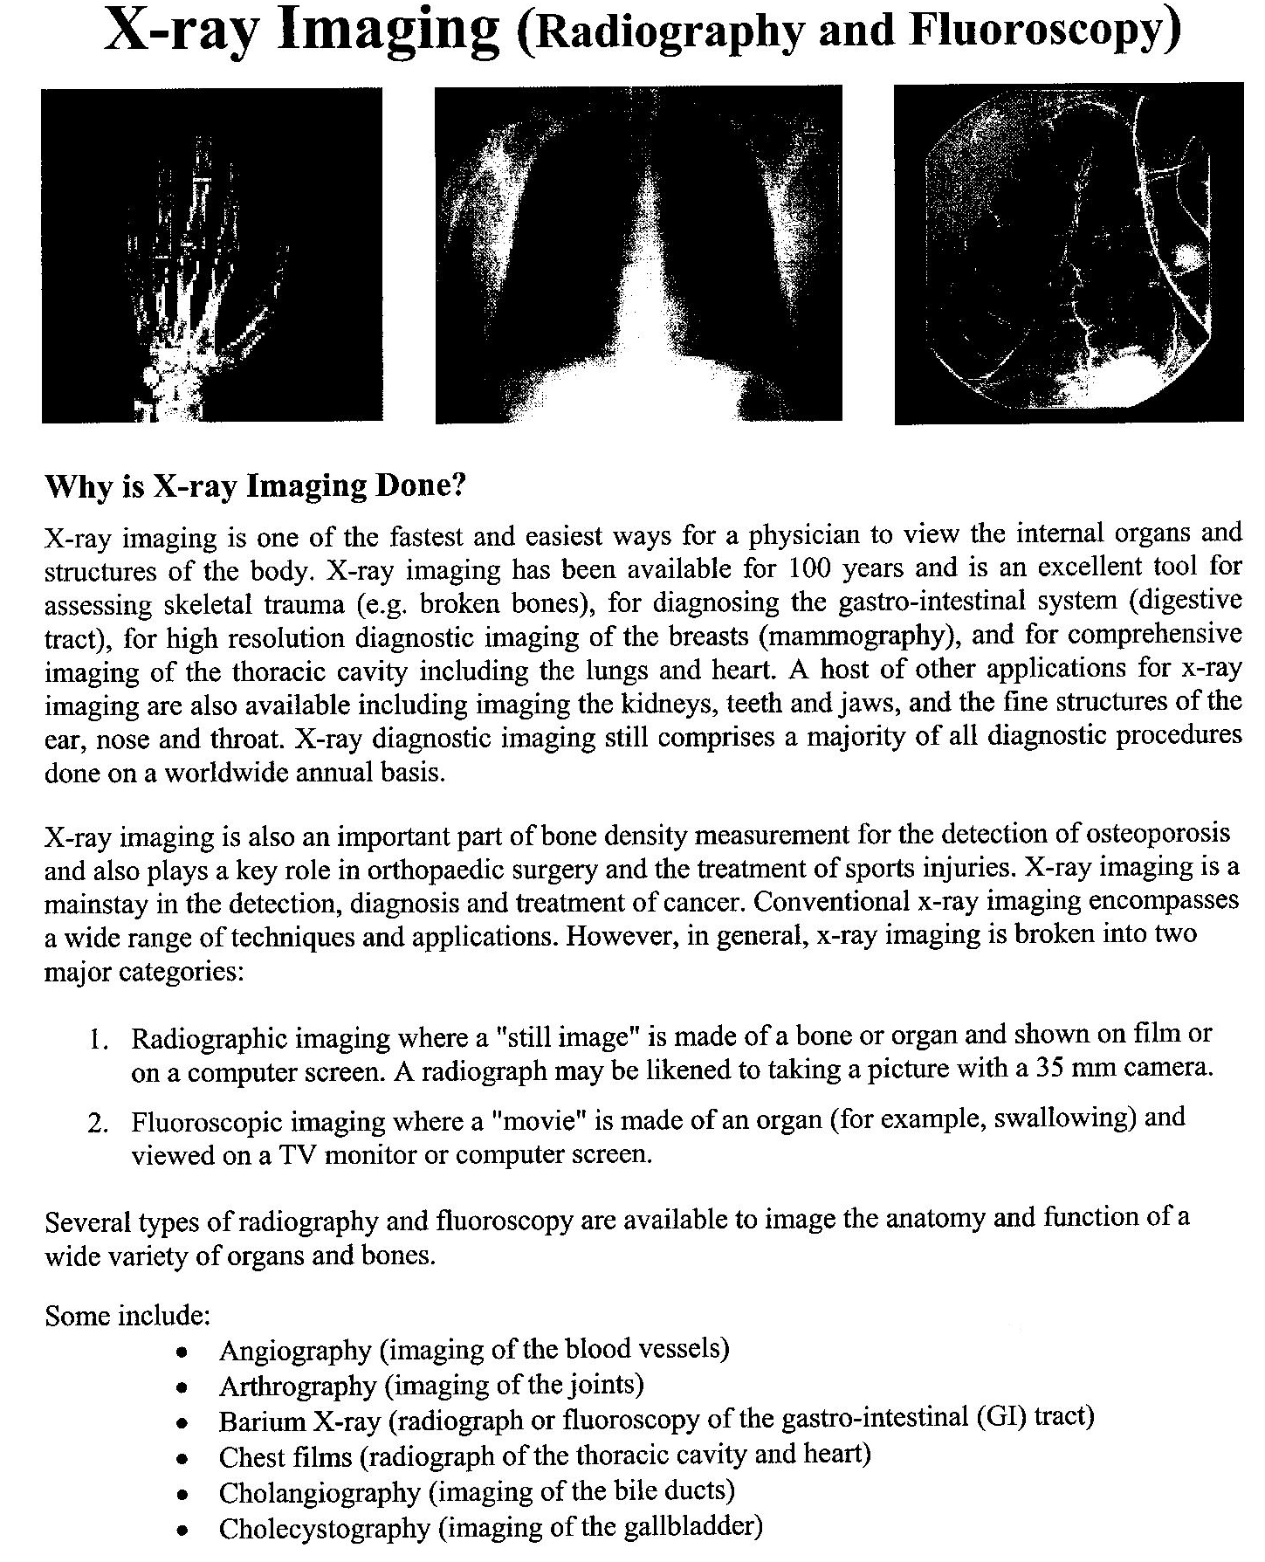

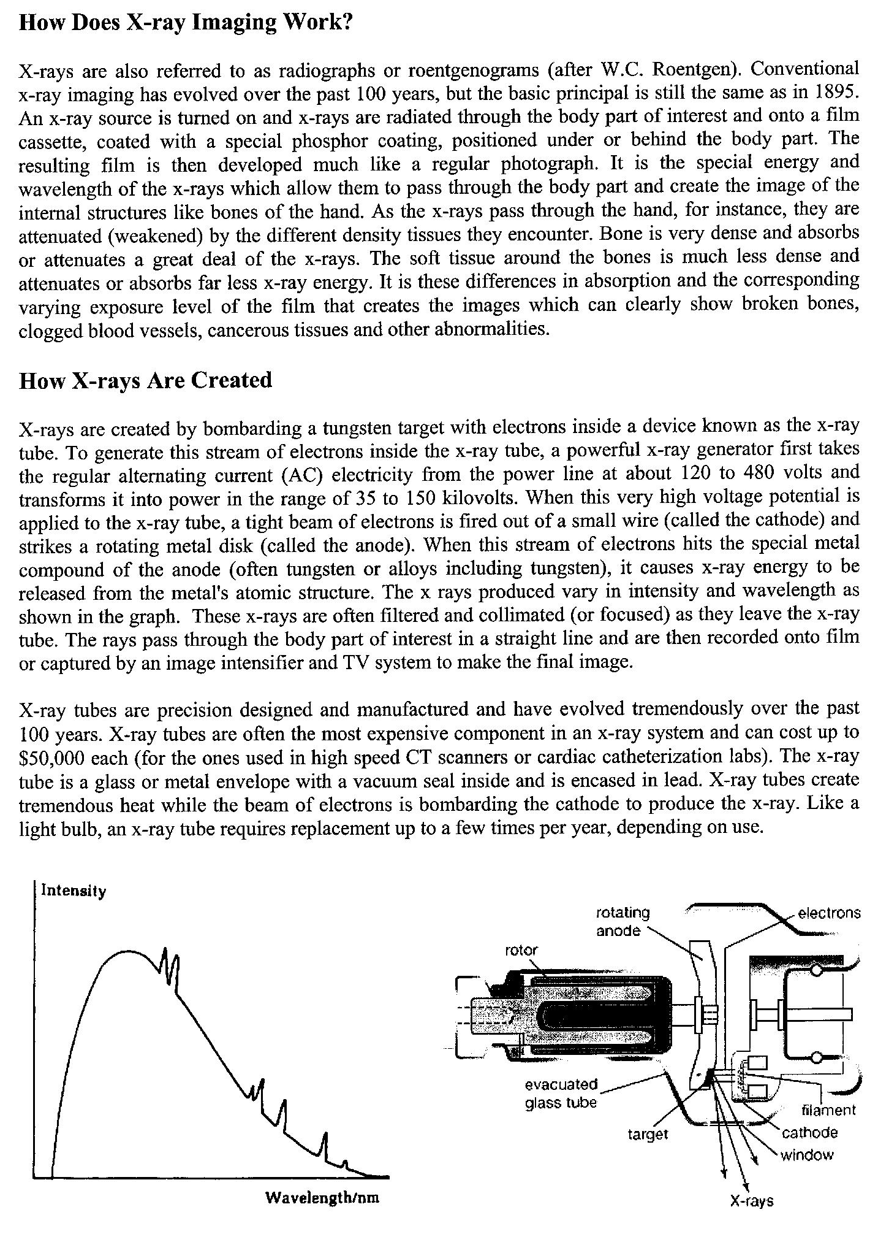

a) Describe some of the applications that X-ray imaging is put to. (2)

_________________________________________________________________________________________________________________________________________________________________________________________________________________________________

___________________________________________________________________________

b) What would be the function of the phosphor coating in the film cassette? (2)

____________________________________________________________________________________________________________________________________________________________________________________________________________________________________________________________________________________________________________

c) Explain why in an X-ray, bone appears to be white, while soft tissue appears dark. (2) ____________________________________________________________________________________________________________________________________________________________________________________________________________________________________________________________________________________________________________

d) Why is it necessary to rotate the anode? (1)

_________________________________________________________________________________________________________________________________________________________________________________________________________________________________

e) What are the spikes on the graph of Intensity versus Wavelength due to? (1)

_________________________________________________________________________________________________________________________________________________________________________________________________________________________________

f) What happens to these spikes if the voltage across the tube is increased? (1)

______________________________________________________________________________________________________________________________________________________

g) What happens to the spikes if the material of the target is changed? (1)

______________________________________________________________________________________________________________________________________________________

h) X-ray tubes are evacuated and encased in lead. Give a reason for each measure. (2)

____________________________________________________________________________________________________________________________________________________________________________________________________________________________________________________________________________________________________________

i) For the X-ray tube described, determine the maximum energy of an electron striking the   
 target. (3)

____________________________________________________________________________________________________________________________________________________________________________________________________________________________________________________________________________________________________________

___________________________________________________________________________

j) Calculate the maximum frequency of the emitted X-rays. What assumption(s) have you   
 made in your calculations? (3)

____________________________________________________________________________________________________________________________________________________________________________________________________________________________________________________________________________________________________________

______________________________________________________________________________________________________________________________________________________

k) Calculate the minimum wavelength of the emitted X-rays. (2)

______________________________________________________________________________________________________________________________________________________

______________________________________________________________________________________________________________________________________________________